**LAB 9  
Creating Multiple EC2 Instances with for each in Terraform**

**STEP 1: Create a new Directory.**



**STEP 2: Create terraform configuration file (main.tf)**

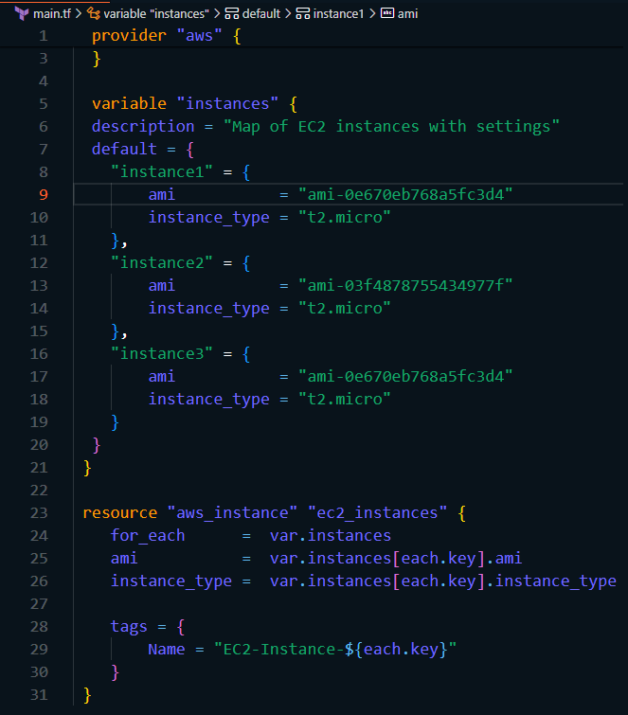

In this Configuration, we define a variable instance as a map containing settings for each EC2 instance. The aws_instances resource is then used with for_each to create instances based on the map.

**STEP 3: Initialize and apply.**

* **terraform init**

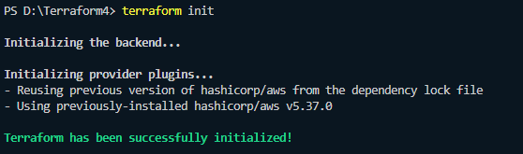

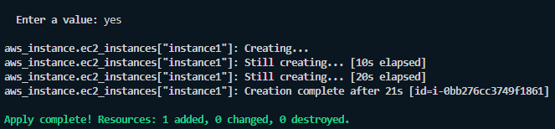

* **terraform apply**

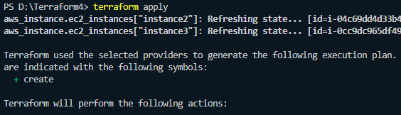

**STEP 4: Verify resources in AWS console.**

* Verify that the resources with the specified names and settings have been created.

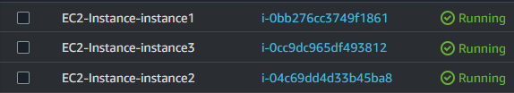

**STEP 5: Clean up.**

* After testing, we clean up the used resources by terraform destroy.

